Mask-Afr-Nigeria-Koruba-Female head-bronze

This head 9 in. x 5 in. is very similar to that in the Dr. Audoin collection, Paris (Dark 1973, pl. 17): "This head with the high collar under the chin falls within the middle range of the memorial heads considered to be the earliest bronze heads produced at Benin ... . This particular one may have been made at the end of the fourteenth century. It is close to the Lagos head [pl 3 below] which it may postdate a little . The tattooed marks on the forehead between the supra-orbital keloids are marked by two strips of iron laid into the bronze. The pupils are of iron. The ear has been flattened probably by a slight shift in the investment when being fired, or at pouring." This bronze is probably the same date as the Audoin collection specimen, since the iron inlays were never applied to this example, which would have been certainly filled in by any imitator.

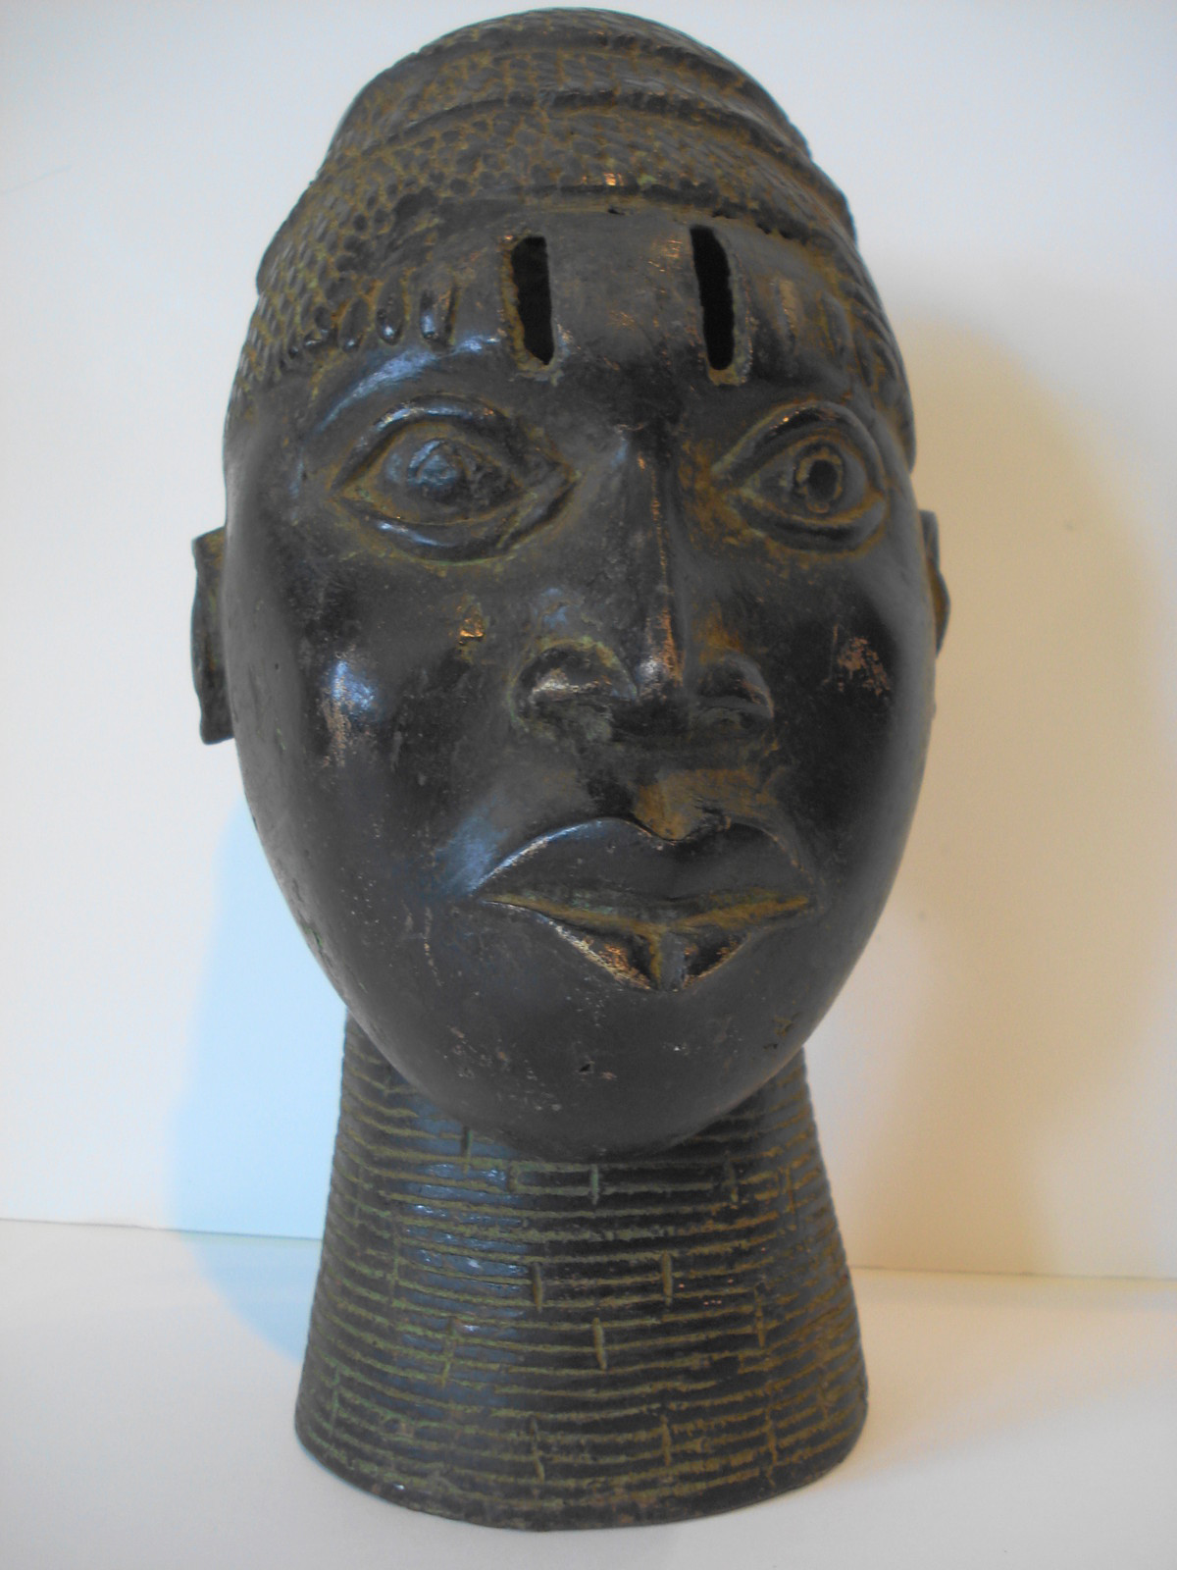

Pl. 1 Atlantika specimen.

